**SOAR Access Request in One IDM**

If you want to add new responsibility in SOAR, you must apply for the Role from One IDM.

Step 1: log in to <https://oneidm.ge.com/faces/home.xhtml>. In the Request Access Search panel search with SOAR.

Step 2: Click on **Supplier Onboarding - GE Healthcare.**

Step 3: Then Click on **Request Access**.  
  
Step 4: In the Action field select **Add** from the drop down.   
  
Step 5: In the Access field select the Responsibility from drop down which you want to add. Then click on **Add to request**.

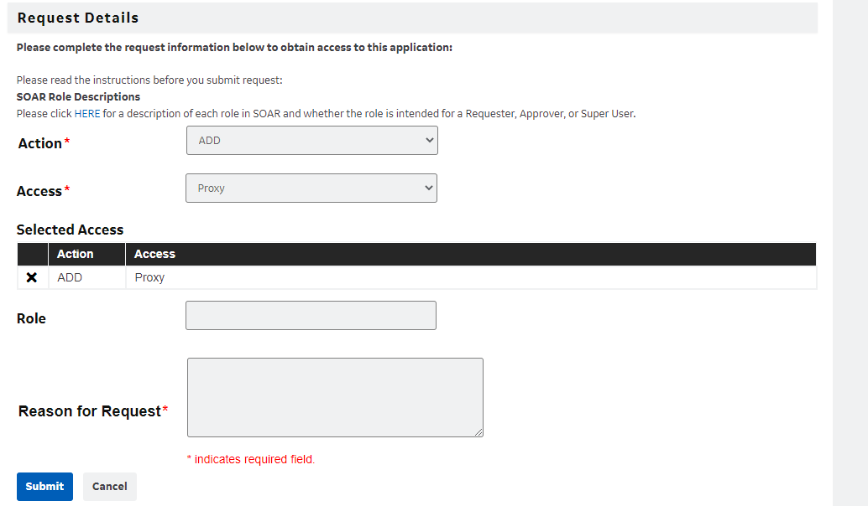

Step 6: Mention the **Reason for Request** and Click on **submit.   
  
**